## 3.2 Render System

Render system is responsible for rendering game data, displaying user interface and handling user actions on menus.

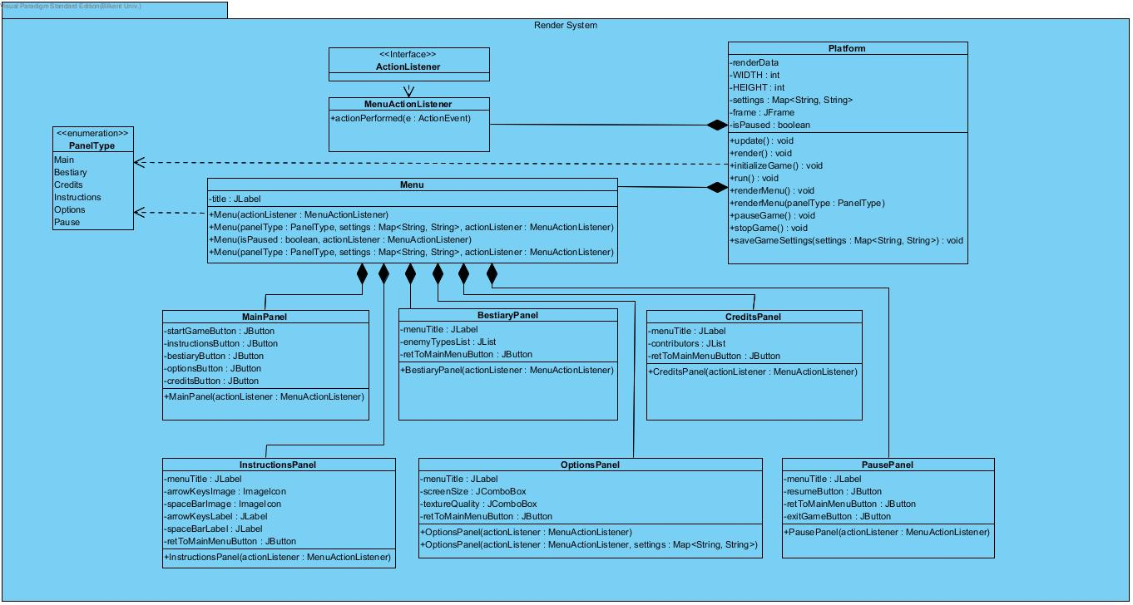

Figure # - Render System

3.2.1 Platform Class

Platform class is the first class instantiated when game first runs. Then it instantiates Menu Class with Main PanelType to display Main Menu to user. It also handles the user’s interaction with menu items like buttons, combo boxes. When user presses start game button, it instantiates GameManager class and starts game loop which calls update and render methods repeatedly.

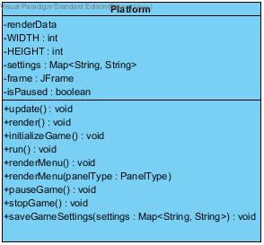

Figure # - Platform Class

3.2.2 MenuActionListener Class

Platform class instantiates MenuActionListener class and passes its reference to Menu Class then Menu Class passes that reference to all panel classes for handling user interactions with menu items. It implements ActionListener interface which forces to implement actionPerformed() method. This class decides what action needs to be taken when user interacts with a specific menu item.

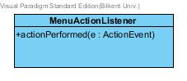

Figure # - MenuActionListener class

3.2.3 Menu Class

Menu class extends JPanel class from swing library. It is initialized by Platform class. It includes a label which contains game title. It uses the parameter that is passed from platform class to instantiate one of the panel classes accordingly.

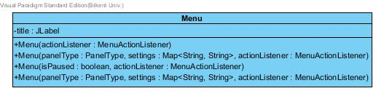

Figure # - Menu class

If it is passes Main Panel type it instantiates MainPanel.

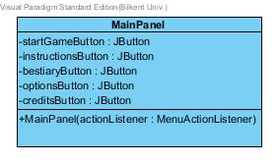

Figure # - MainPanel class

If it passes Bestiary Panel type it instantiates BestiaryPanel

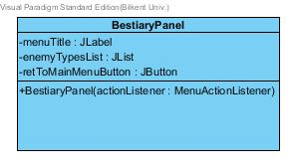

Figure # - BestiaryPanel class

If it passes Credits Panel type it instantiates CreditsPanel

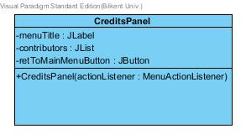

Figure # - CreditsPanel class

If it passes Instructions Panel type it instantiates InstructionsPanel.

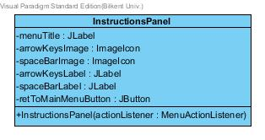

Figure # - InstructionsPanel class

If it passes Options Panel type with settings variable it instantiates OptionsPanel with the given settings data.

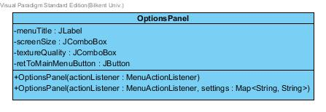

Figure # - OptionsPanel class

If it passes PausePanel type and isPaused variable is true, it instantiates PausePanel.

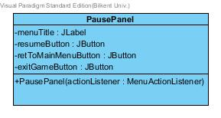

Figure # - PausePanel Class